Exercise 1: Configuring a Basic Spring Application (MANDATORY)

Folder Structure:
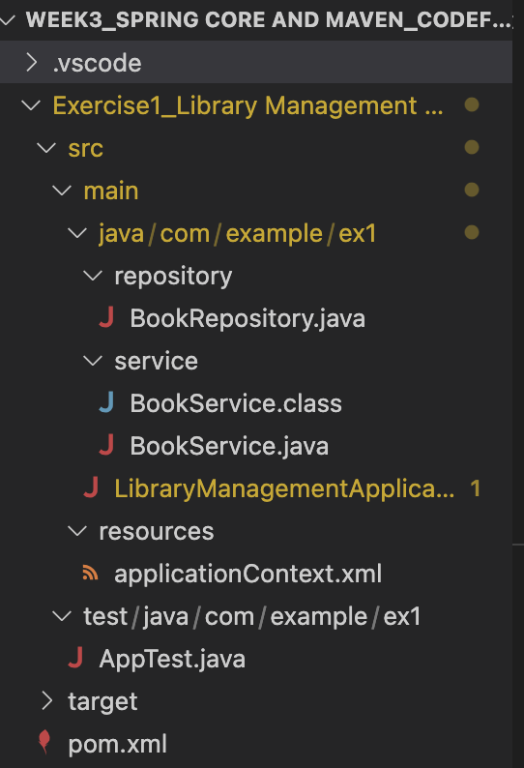

BookRepository.java:

package com.example.ex1.repository;

public class BookRepository {
public void fetchBooks() {
System.out.println("BookRepository: Fetching books from the database.");
}
}

BookService.java:

package com.example.ex1.service;

public class BookService {
public void displayBookInfo() {
System.out.println("BookService: Displaying book information.");
}
}

LibraryManagementApplication.java:

package com.example.ex1;
import org.springframework.context.ApplicationContext;
import org.springframework.context.support.ClassPathXmlApplicationContext;

import com.example.ex1.repository.BookRepository;
import com.example.ex1.service.BookService;

public class LibraryManagementApplication {
public static void main(String[] args) {
ApplicationContext c = new ClassPathXmlApplicationContext("applicationContext.xml");
BookService bs = c.getBean("bookService", BookService.class);
BookRepository br = c.getBean("bookRepository", BookRepository.class);
bs.displayBookInfo();
br.fetchBooks();
}
}

applicationContext.xml:

<?xml version="1.0" encoding="UTF-8"?>
<beans xmlns="http://www.springframework.org/schema/beans"
xmlns:xsi="http://www.w3.org/2001/XMLSchema-instance"
xsi:schemaLocation="http://www.springframework.org/schema/beans
http://www.springframework.org/schema/beans/spring-beans.xsd">
<bean id="bookService" class="com.example.ex1.service.BookService"/>
<bean id="bookRepository" class="com.example.ex1.repository.BookRepository"/>
</beans>

pom.xml:
<?xml version="1.0" encoding="UTF-8"?>

<project xmlns="http://maven.apache.org/POM/4.0.0"
xmlns:xsi="http://www.w3.org/2001/XMLSchema-instance"
xsi:schemaLocation="http://maven.apache.org/POM/4.0.0
http://maven.apache.org/xsd/maven-4.0.0.xsd">

<modelVersion>4.0.0</modelVersion>
<groupId>com.example.ex1</groupId>
<artifactId>library_management</artifactId>
<version>1.0-SNAPSHOT</version>
<name>library_management</name>
<properties>
<project.build.sourceEncoding>UTF-8</project.build.sourceEncoding>
<maven.compiler.source>1.8</maven.compiler.source>
<maven.compiler.target>1.8</maven.compiler.target>
</properties>
<dependencies>
<dependency>
<groupId>org.springframework</groupId>
<artifactId>spring-context</artifactId>
<version>5.3.36</version>
</dependency>
<dependency>
<groupId>junit</groupId>
<artifactId>junit</artifactId>
<version>4.11</version>
<scope>test</scope>
</dependency>
</dependencies>
<build>
<plugins>
<plugin>
<artifactId>maven-compiler-plugin</artifactId>
<version>3.8.0</version>
<configuration>
<source>1.8</source>
<target>1.8</target>
</configuration>
</plugin>
</plugins>
</build>

</project>

Output:

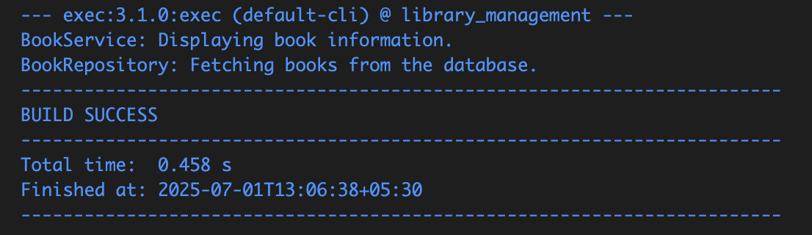

BookService: Displaying book information.
BookRepository: Fetching books from the database.

Exercise 2: Implementing Dependency Injection (MANDATORY)

Folder Structure:
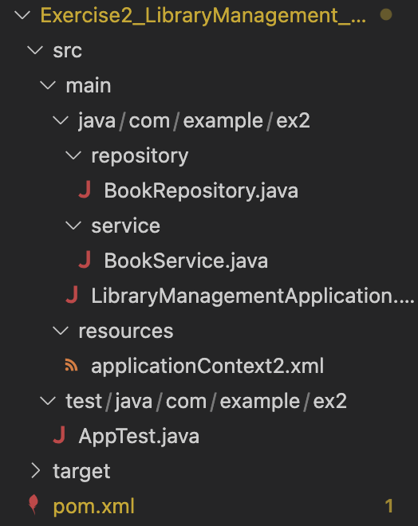

BookRepository.java:
package com.example.ex2.repository;

public class BookRepository {
public void fetchBooks() {
System.out.println("BookRepository: Fetching books from the database.");
}
}

BookService.java:
package com.example.ex2.service;
import com.example.ex2.repository.BookRepository;

public class BookService {

private BookRepository br;

public void setBookRepository(BookRepository br) {
this.br = br;
}
public void displayBookInfo() {
System.out.println("BookService: Displaying book information.");
br.fetchBooks();
}
}

LibraryManagementApplication:
package com.example.ex2;
import org.springframework.context.ApplicationContext;
import org.springframework.context.support.ClassPathXmlApplicationContext;
import com.example.ex2.service.BookService;

public class LibraryManagementApplication {
public static void main(String[] args) {
ApplicationContext c = new ClassPathXmlApplicationContext("applicationContext2.xml");

BookService bs = c.getBean("bookService", BookService.class);
bs.displayBookInfo();
}
}

applicationContext.xml:

<<?xml version="1.0" encoding="UTF-8"?>
<beans xmlns="http://www.springframework.org/schema/beans"
xmlns:xsi="http://www.w3.org/2001/XMLSchema-instance"
xsi:schemaLocation="http://www.springframework.org/schema/beans
http://www.springframework.org/schema/beans/spring-beans.xsd">

<bean id="bookRepository" class="com.example.ex2.repository.BookRepository" /> <bean id="bookService" class="com.example.ex2.service.BookService">
<property name="bookRepository" ref="bookRepository" />
</bean>

</beans>

pom.xml:

<?xml version="1.0" encoding="UTF-8"?>
<project xmlns="http://maven.apache.org/POM/4.0.0"
xmlns:xsi="http://www.w3.org/2001/XMLSchema-instance"
xsi:schemaLocation="http://maven.apache.org/POM/4.0.0
http://maven.apache.org/xsd/maven-4.0.0.xsd">
<modelVersion>4.0.0</modelVersion>
<groupId>com.example.ex2</groupId>
<artifactId>library_management_di</artifactId>
<version>1.0-SNAPSHOT</version>
<properties>
<project.build.sourceEncoding>UTF-8</project.build.sourceEncoding>
<maven.compiler.source>1.8</maven.compiler.source>
<maven.compiler.target>1.8</maven.compiler.target>
</properties>
<dependencies>
<dependency>
<groupId>org.springframework</groupId>
<artifactId>spring-context</artifactId>
<version>5.3.36</version>
</dependency>
</dependencies>
<build>
<plugins>
<plugin>
<artifactId>maven-compiler-plugin</artifactId>
<version>3.8.0</version>
<configuration>
<source>1.8</source>
<target>1.8</target>
</configuration>
</plugin>
<plugin>
<groupId>org.codehaus.mojo</groupId>
<artifactId>exec-maven-plugin</artifactId>
<version>3.1.0</version>
<configuration>
<mainClass>com.example.ex2.LibraryManagementApplication</mainClass>
</configuration>
</plugin>
</plugins>
</build>
</project>

Output:

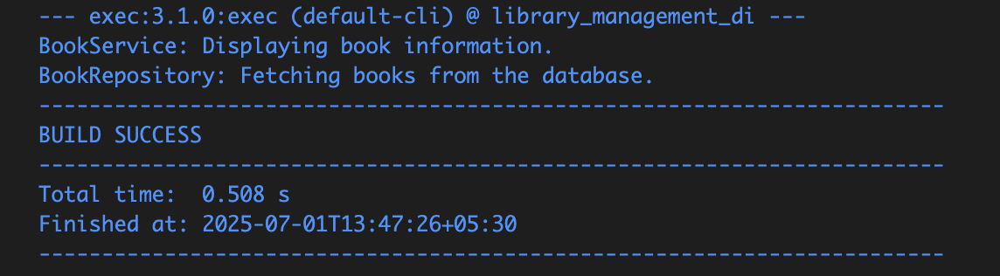

BookService: Displaying book information.
BookRepository: Fetching books from the database.

Exercise 3: Implementing Logging with Spring AOP

Folder Structure
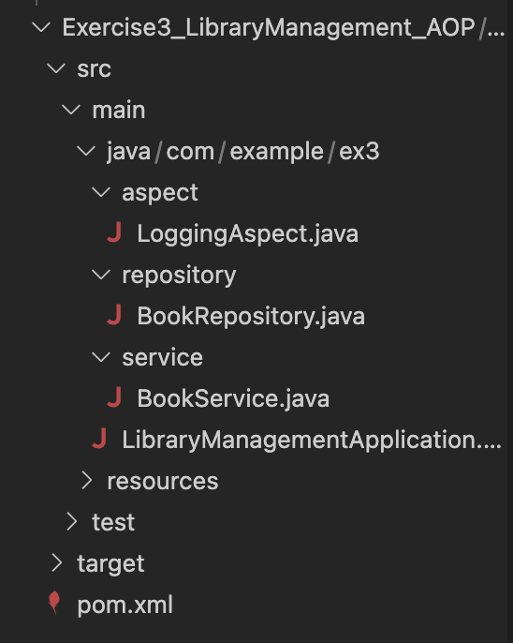

LoggingAspect.java:
package com.example.ex3.aspect;
import org.aspectj.lang.ProceedingJoinPoint;
import org.aspectj.lang.annotation.Around;
import org.aspectj.lang.annotation.Aspect;

@Aspect
public class LoggingAspect {

@Around("execution(* com.example.ex3.service.*.*(..))")
public Object logExecutionTime(ProceedingJoinPoint joinPoint) throws Throwable {
long s = System.currentTimeMillis();
Object res = joinPoint.proceed();
long e = System.currentTimeMillis();
System.out.println("Method " + joinPoint.getSignature().getName() +" executed in " + (e - s) + "ms");
return res;
}
}

BookRepository.java:
package com.example.ex3.repository;
public class BookRepository {
public void fetchBooks() {
System.out.println(" BookRepository: Fetching books from DB...");
}
}
BookService.java:
package com.example.ex3.service;
import com.example.ex3.repository.BookRepository;

public class BookService {
private BookRepository br;
public void setBookRepository(BookRepository br) {
this.br = br;
}
public void displayBookInfo() {
System.out.println("BookService: Displaying book information...");
br.fetchBooks();
}
}

LibraryManagementApplication:
package com.example.ex3;
import org.springframework.context.support.ClassPathXmlApplicationContext;
import com.example.ex3.service.BookService;
public class LibraryManagementApplication {
public static void main(String[] args) {
try (ClassPathXmlApplicationContext context = new ClassPathXmlApplicationContext("applicationContext.xml")) {
BookService bs = context.getBean("bookService", BookService.class);
bs.displayBookInfo();
}
}
}

applicationContext.xml:
<?xml version="1.0" encoding="UTF-8"?>
<beans xmlns="http://www.springframework.org/schema/beans"
xmlns:xsi="http://www.w3.org/2001/XMLSchema-instance"
xmlns:aop="http://www.springframework.org/schema/aop"
xsi:schemaLocation="
http://www.springframework.org/schema/beans
http://www.springframework.org/schema/beans/spring-beans.xsd
http://www.springframework.org/schema/aop
http://www.springframework.org/schema/aop/spring-aop.xsd">
<aop:aspectj-autoproxy />
<bean id="bookRepository" class="com.example.ex3.repository.BookRepository" />
<bean id="bookService" class="com.example.ex3.service.BookService">
<property name="bookRepository" ref="bookRepository" />
</bean>
<bean id="loggingAspect" class="com.example.ex3.aspect.LoggingAspect" />
</beans>
pom.xml:
<project xmlns="http://maven.apache.org/POM/4.0.0"
xmlns:xsi="http://www.w3.org/2001/XMLSchema-instance"
xsi:schemaLocation="http://maven.apache.org/POM/4.0.0
http://maven.apache.org/xsd/maven-4.0.0.xsd">
<modelVersion>4.0.0</modelVersion>

<groupId>com.example.ex3</groupId>
<artifactId>library_management_aop</artifactId>
<version>1.0-SNAPSHOT</version>

<properties>
<maven.compiler.release>21</maven.compiler.release>
<project.build.sourceEncoding>UTF-8</project.build.sourceEncoding>
</properties>

<dependencies>
<dependency>
<groupId>org.springframework</groupId>
<artifactId>spring-context</artifactId>
<version>5.3.36</version>
</dependency>

<dependency>
<groupId>org.springframework</groupId>
<artifactId>spring-aspects</artifactId>
<version>5.3.36</version>
</dependency>

<dependency>
<groupId>org.aspectj</groupId>
<artifactId>aspectjweaver</artifactId>
<version>1.9.21</version>
</dependency>
</dependencies>

<build>
<plugins>
<plugin>
<groupId>org.codehaus.mojo</groupId>
<artifactId>exec-maven-plugin</artifactId>
<version>3.1.0</version>
<configuration>
<mainClass>com.example.ex3.LibraryManagementApplication</mainClass>
</configuration>
</plugin>
</plugins>
</build>
</project>

Output:

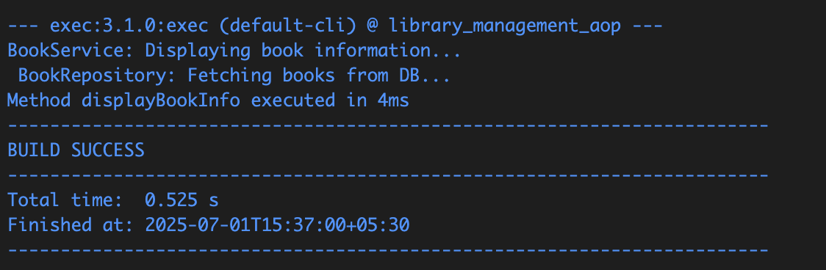

BookService: Displaying book information...
BookRepository: Fetching books from DB...
Method displayBookInfo executed in 4ms

Exercise 4: Creating and Configuring a Maven Project (MANDATORY)

Folder Structure:
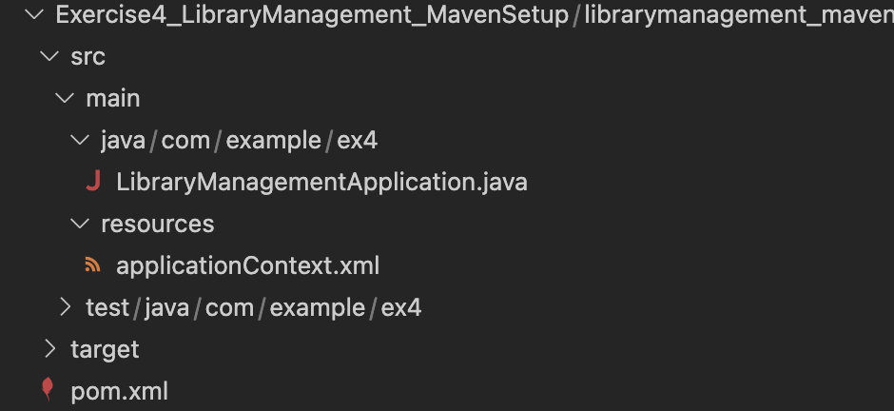

LibraryManagementApplication.java:
package com.example.ex4;

public class LibraryManagementApplication {
public static void main(String[] args) {
System.out.println("Library Management Project Setup Completed!");
}
}

applicationContext.xml:

<beans xmlns="http://www.springframework.org/schema/beans"
xmlns:xsi="http://www.w3.org/2001/XMLSchema-instance"
xsi:schemaLocation="
http://www.springframework.org/schema/beans
http://www.springframework.org/schema/beans/spring-beans.xsd">

<bean id="exampleBean" class="java.lang.String">
<constructor-arg value="Spring Bean Initialized" />
</bean>
</beans>

pom.xml:
<project xmlns="http://maven.apache.org/POM/4.0.0"
xmlns:xsi="http://www.w3.org/2001/XMLSchema-instance"
xsi:schemaLocation="http://maven.apache.org/POM/4.0.0
http://maven.apache.org/xsd/maven-4.0.0.xsd">

<modelVersion>4.0.0</modelVersion>

<groupId>com.example.ex4</groupId>
<artifactId>LibraryManagement</artifactId>
<version>1.0-SNAPSHOT</version>

<properties>
<project.build.sourceEncoding>UTF-8</project.build.sourceEncoding>
<maven.compiler.source>1.8</maven.compiler.source>
<maven.compiler.target>1.8</maven.compiler.target>
</properties>

<dependencies>

<dependency>
<groupId>org.springframework</groupId>
<artifactId>spring-context</artifactId>
<version>5.3.36</version>
</dependency>

<dependency>
<groupId>org.springframework</groupId>
<artifactId>spring-aspects</artifactId>
<version>5.3.36</version>
</dependency>

<dependency>
<groupId>org.springframework</groupId>
<artifactId>spring-webmvc</artifactId>
<version>5.3.36</version>
</dependency>
</dependencies>
<build>
<plugins>
<plugin>
<artifactId>maven-compiler-plugin</artifactId>
<version>3.8.0</version>
<configuration>
<source>1.8</source>
<target>1.8</target>
</configuration>
</plugin>
</plugins>
</build>
</project>

Output:

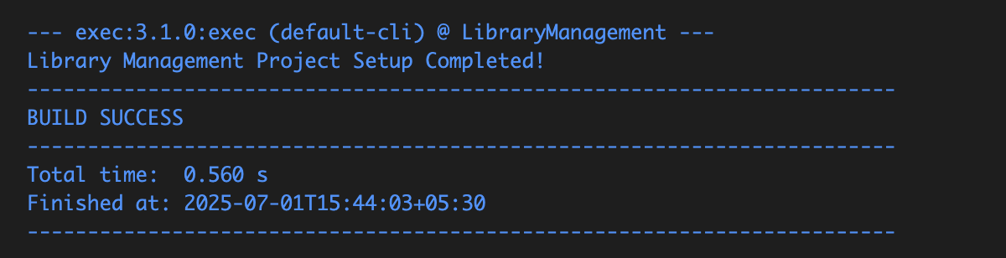

Exercise 5: Configuring the Spring IoC Container

Folder Structure:
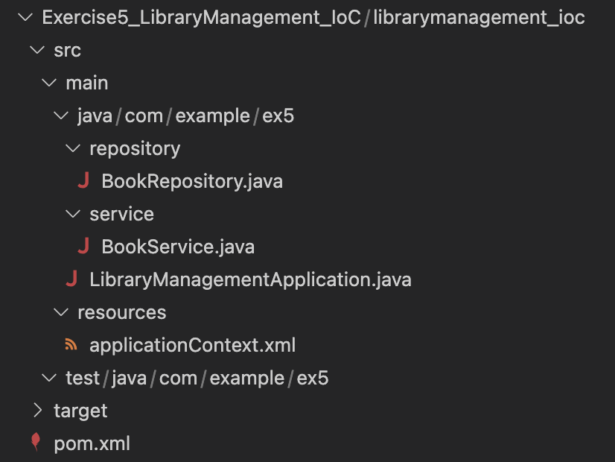

BookRepository.java:
package com.example.ex5.repository;

public class BookRepository {
public void fetchBooks() {
System.out.println(" BookRepository: Fetching books from the database...");
}
}

BookService.java:
package com.example.ex5.service;

import com.example.ex5.repository.BookRepository;

public class BookService {
private BookRepository br;

public void setBookRepository(BookRepository br) {
this.br = br;
}

public void displayBookInfo() {
System.out.println(" BookService: Displaying book information...");
br.fetchBooks();
}
}

LibraryManagementApplication.java:
package com.example.ex5;

import org.springframework.context.support.ClassPathXmlApplicationContext;

import com.example.ex5.service.BookService;

public class LibraryManagementApplication {
public static void main(String[] args) {
try (ClassPathXmlApplicationContext c =
new ClassPathXmlApplicationContext("applicationContext.xml")) {

BookService bs = c.getBean("bookService", BookService.class);
bs.displayBookInfo();
}
}
}

applicationContext.xml:

<?xml version="1.0" encoding="UTF-8"?>
<beans xmlns="http://www.springframework.org/schema/beans"
xmlns:xsi="http://www.w3.org/2001/XMLSchema-instance"
xsi:schemaLocation="
http://www.springframework.org/schema/beans
http://www.springframework.org/schema/beans/spring-beans.xsd">

<bean id="bookRepository" class="com.example.ex5.repository.BookRepository" />

<bean id="bookService" class="com.example.ex5.service.BookService">
<property name="bookRepository" ref="bookRepository" />
</bean>
</beans>

pom.xml:

<project xmlns="http://maven.apache.org/POM/4.0.0"
xmlns:xsi="http://www.w3.org/2001/XMLSchema-instance"
xsi:schemaLocation="http://maven.apache.org/POM/4.0.0
http://maven.apache.org/xsd/maven-4.0.0.xsd">
<modelVersion>4.0.0</modelVersion>

<groupId>com.example.ex5</groupId>
<artifactId>LibraryManagementIoC</artifactId>
<version>1.0-SNAPSHOT</version>

<properties>
<maven.compiler.source>1.8</maven.compiler.source>
<maven.compiler.target>1.8</maven.compiler.target>
<project.build.sourceEncoding>UTF-8</project.build.sourceEncoding>
</properties>

<dependencies>
<dependency>
<groupId>org.springframework</groupId>
<artifactId>spring-context</artifactId>
<version>5.3.36</version>
</dependency>
</dependencies>
</project>

Output:

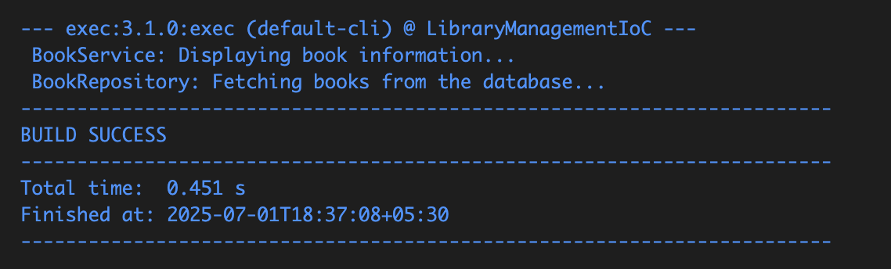

BookService: Displaying book information...
BookRepository: Fetching books from the database...

Exercise 6: Configuring Beans with Annotations

Folder Structure:
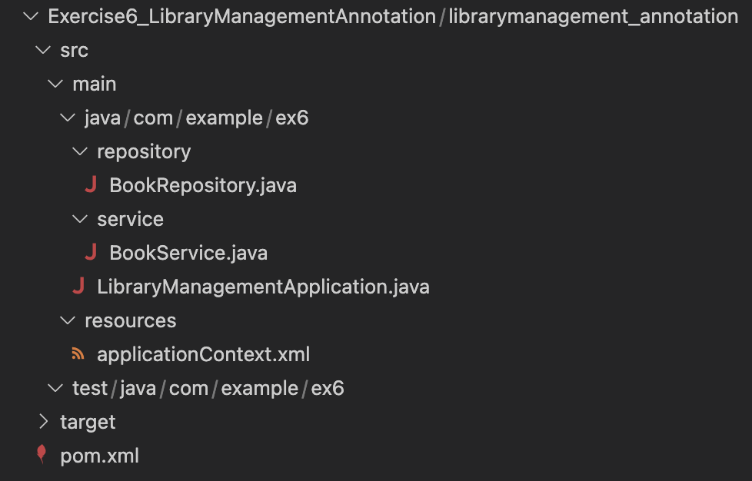

BookRepository:

package com.example.ex6.repository;
import org.springframework.stereotype.Repository;
@Repository
public class BookRepository {
public void fetchBooks() {
System.out.println("📘 BookRepository: Fetching books from the database...");
}
}

BookService.java:

package com.example.ex6.service;
import org.springframework.beans.factory.annotation.Autowired;
import org.springframework.stereotype.Service;
import com.example.ex6.repository.BookRepository;
@Service
public class BookService {
private BookRepository br;
@Autowired
public void setBookRepository(BookRepository br) {
this.br = br;
}
public void displayBookInfo() {
System.out.println("📚 BookService: Displaying book info...");
br.fetchBooks();
}
}
LibraryManagementApplication.java:

package com.example.ex6;
import org.springframework.context.support.ClassPathXmlApplicationContext;
import com.example.ex6.service.BookService;

public class LibraryManagementApplication {
public static void main(String[] args) {
try (ClassPathXmlApplicationContext c =
new ClassPathXmlApplicationContext("applicationContext.xml")) {
BookService bs = c.getBean(BookService.class);
bs.displayBookInfo();
}
}
}

applicationContext.xml:

<?xml version="1.0" encoding="UTF-8"?>
<beans xmlns="http://www.springframework.org/schema/beans"
xmlns:xsi="http://www.w3.org/2001/XMLSchema-instance"
xmlns:context="http://www.springframework.org/schema/context"
xsi:schemaLocation="
http://www.springframework.org/schema/beans
http://www.springframework.org/schema/beans/spring-beans.xsd
http://www.springframework.org/schema/context
http://www.springframework.org/schema/context/spring-context.xsd">

<context:component-scan base-package="com.example.ex6" />
</beans>

pom.xml:

<project xmlns="http://maven.apache.org/POM/4.0.0"
xmlns:xsi="http://www.w3.org/2001/XMLSchema-instance"
xsi:schemaLocation="http://maven.apache.org/POM/4.0.0
http://maven.apache.org/xsd/maven-4.0.0.xsd">

<modelVersion>4.0.0</modelVersion>
<groupId>com.example.ex6</groupId>
<artifactId>library_management_annotations</artifactId>
<version>1.0-SNAPSHOT</version>

<properties>
<maven.compiler.release>21</maven.compiler.release>
<project.build.sourceEncoding>UTF-8</project.build.sourceEncoding>
</properties>

<dependencies>
<dependency>
<groupId>org.springframework</groupId>
<artifactId>spring-context</artifactId>
<version>5.3.36</version>
</dependency>
</dependencies>

<build>
<plugins>
<plugin>
<groupId>org.codehaus.mojo</groupId>
<artifactId>exec-maven-plugin</artifactId>
<version>3.1.0</version>
<configuration>
<mainClass>com.example.ex6.LibraryManagementApplication</mainClass>
</configuration>
</plugin>
</plugins>
</build>
</project>

Output:

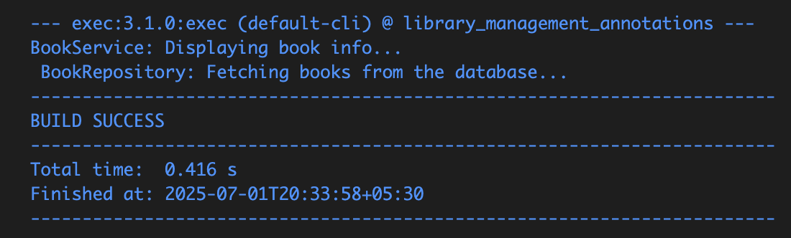

BookService: Displaying book info...
BookRepository: Fetching books from the database…

Exercise 7: Implementing Constructor and Setter Injection

Folder Structure:
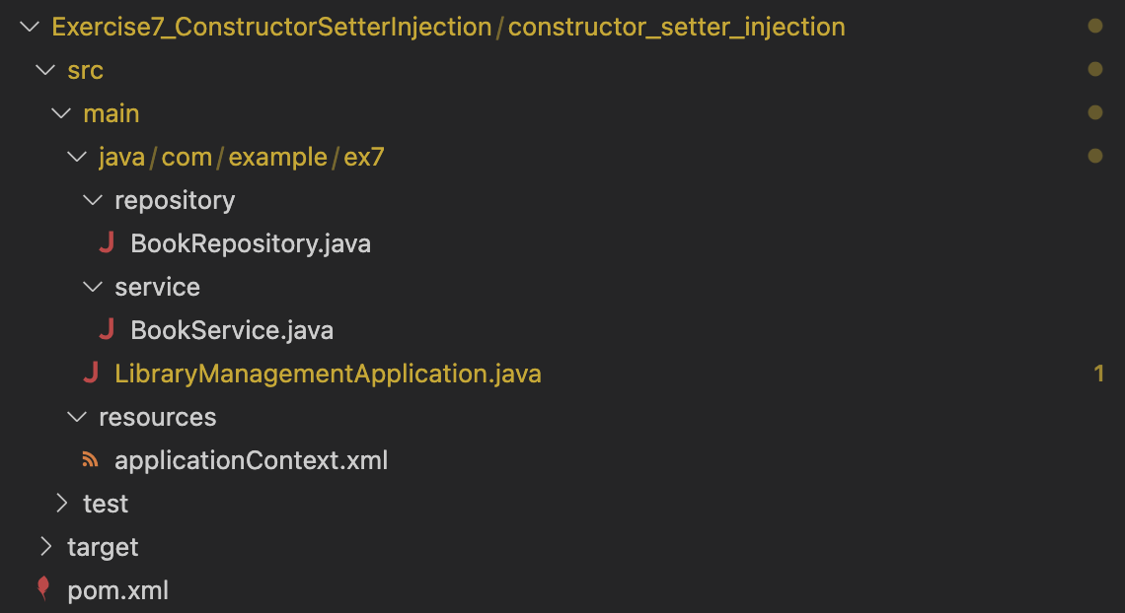

BookRepository.java:
package com.example.ex7.repository;

public class BookRepository {
public void printRepositoryInfo() {
System.out.println(" BookRepository: Accessing book data...");
}
}

BookService.java:
package com.example.ex7.service;

import com.example.ex7.repository.BookRepository;

public class BookService {
private BookRepository br;

public BookService(BookRepository br) {
this.br = br;
System.out.println("Constructor injection used.");
}

public void setBookRepository(BookRepository br) {
this.br = br;
System.out.println("Setter injection used.");
}

public void displayBookInfo() {
System.out.println(" BookService: Displaying book information.");
br.printRepositoryInfo();
}
}

LibraryManagementApplication.java:
package com.example.ex7;

import org.springframework.context.ApplicationContext;
import org.springframework.context.support.ClassPathXmlApplicationContext;

import com.example.ex7.service.BookService;

public class LibraryManagementApplication {
public static void main(String[] args) {
ApplicationContext c = new ClassPathXmlApplicationContext("applicationContext.xml");

BookService bs = (BookService) c.getBean("bookService");
bs.displayBookInfo();
}
}

applicationContext.xml:

<?xml version="1.0" encoding="UTF-8"?>
<beans xmlns="http://www.springframework.org/schema/beans"
xmlns:xsi="http://www.w3.org/2001/XMLSchema-instance"
xsi:schemaLocation="http://www.springframework.org/schema/beans
http://www.springframework.org/schema/beans/spring-beans.xsd">
<bean id="bookRepository" class="com.example.ex7.repository.BookRepository" />

<bean id="bookService" class="com.example.ex7.service.BookService">
<constructor-arg ref="bookRepository" />

<property name="bookRepository" ref="bookRepository" />
</bean>
</beans>

pom.xml:

<?xml version="1.0" encoding="UTF-8"?>

<project xmlns="http://maven.apache.org/POM/4.0.0" xmlns:xsi="http://www.w3.org/2001/XMLSchema-instance"
xsi:schemaLocation="http://maven.apache.org/POM/4.0.0 http://maven.apache.org/xsd/maven-4.0.0.xsd">
<modelVersion>4.0.0</modelVersion>
<groupId>com.example.ex7</groupId>
<artifactId>constructor_setter_injection</artifactId>
<version>1.0-SNAPSHOT</version>
<name>constructor_setter_injection</name>
<url>http://www.example.com</url>
<properties>
<project.build.sourceEncoding>UTF-8</project.build.sourceEncoding>
<maven.compiler.source>1.8</maven.compiler.source>
<maven.compiler.target>1.8</maven.compiler.target>
</properties>
<dependencies>
<dependency>
<groupId>org.springframework</groupId>
<artifactId>spring-context</artifactId>
<version>5.3.32</version>
</dependency>
<dependency>
<groupId>org.springframework</groupId>
<artifactId>spring-beans</artifactId>
<version>5.3.32</version>
</dependency>
<dependency>
<groupId>junit</groupId>
<artifactId>junit</artifactId>
<version>4.11</version>
<scope>test</scope>
</dependency>
</dependencies>
<build>
<pluginManagement>
<plugins>

<plugin>
<artifactId>maven-clean-plugin</artifactId>
<version>3.1.0</version>
</plugin>

<plugin>
<artifactId>maven-resources-plugin</artifactId>
<version>3.0.2</version>
</plugin>
<plugin>
<artifactId>maven-compiler-plugin</artifactId>
<version>3.8.0</version>
</plugin>
<plugin>
<artifactId>maven-surefire-plugin</artifactId>
<version>2.22.1</version>
</plugin>
<plugin>
<artifactId>maven-jar-plugin</artifactId>
<version>3.0.2</version>
</plugin>
<plugin>
<artifactId>maven-install-plugin</artifactId>
<version>2.5.2</version>
</plugin>
<plugin>
<artifactId>maven-deploy-plugin</artifactId>
<version>2.8.2</version>
</plugin>
<plugin>
<artifactId>maven-site-plugin</artifactId>
<version>3.7.1</version>
</plugin>
<plugin>
<artifactId>maven-project-info-reports-plugin</artifactId>
<version>3.0.0</version>
</plugin>
</plugins>
</pluginManagement>
</build>
</project>

Output:
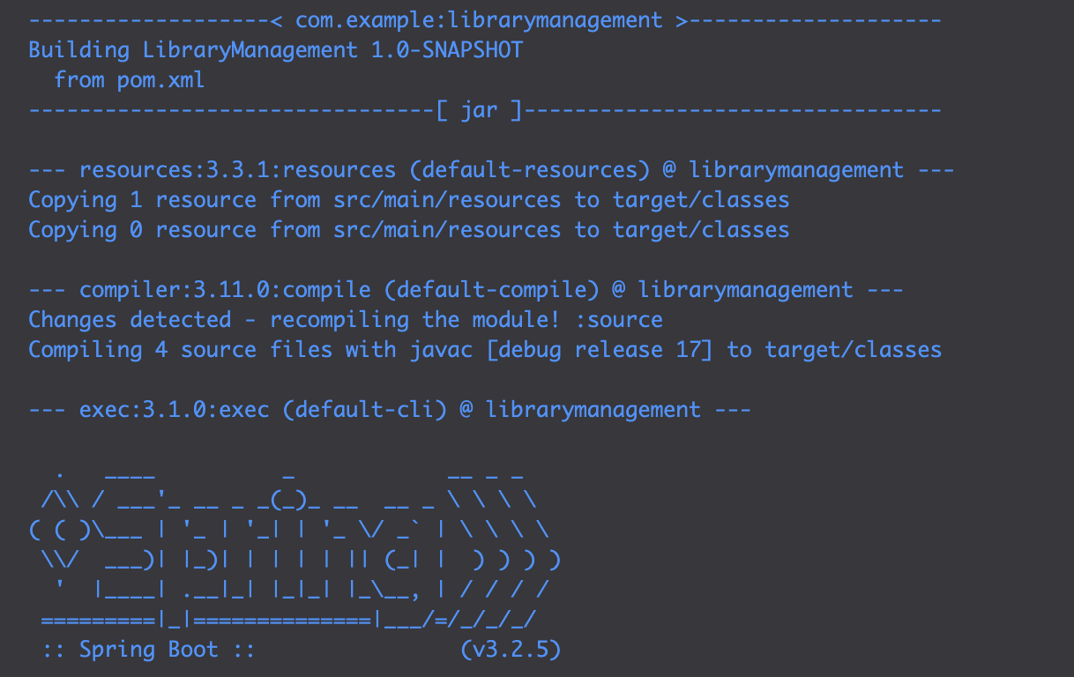
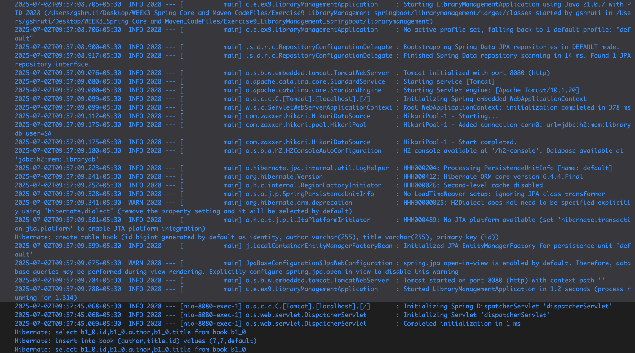

Run and Test the Application

